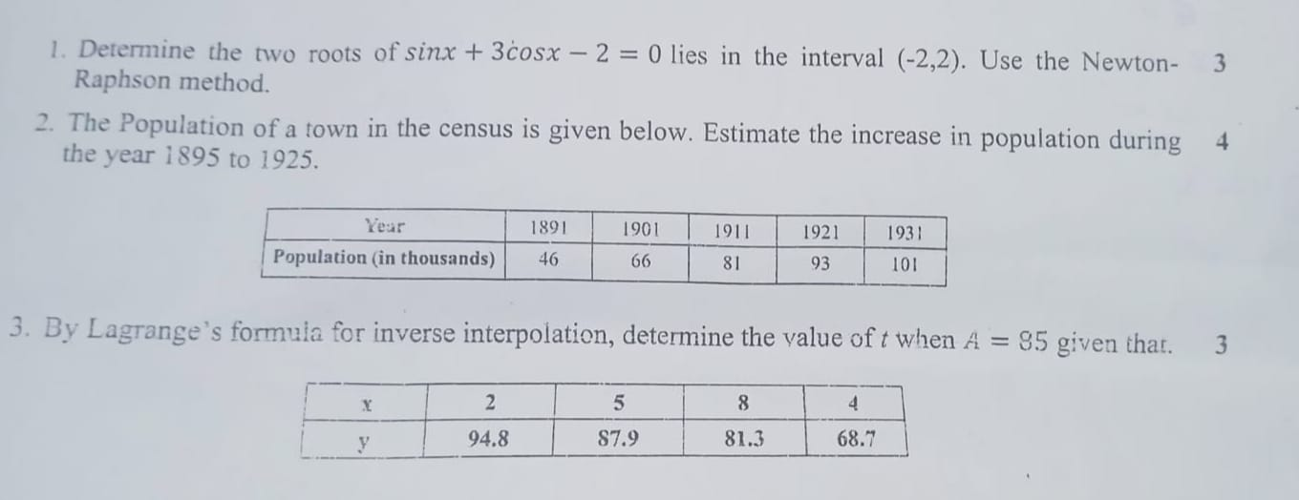

**#CT 1**

**#Question 1**

import numpy as np

import math

def newtonRaphson(f, df, x0, tol=1.0e-9, max_iter=100):

for i in range(max_iter):

fx = f(x0)

dfx = df(x0)

if abs(dfx) < 1e-12: # Avoid division by zero

raise ZeroDivisionError("Derivative too small.")

x1 = x0 - fx / dfx

if abs(x1 - x0) < tol:

return x1, i + 1

x0 = x1

raise RuntimeError("Too many iterations")

# Define the function and its derivative

def f(x):

return math.sin(x) + 3 * math.cos(x) - 2

def df(x):

return math.cos(x) - 3 * math.sin(x)

# Initial guesses (chosen to find two roots in (-2, 2))

x0_list = [-1.0, 1.0]

roots = []

for x0 in x0_list:

root, iterations = newtonRaphson(f, df, x0)

roots.append(root)

print(f"Initial guess: {x0}")

print(f"Root found: {root:.6f}")

print(f"Iterations: {iterations}\n")

**#question 2**

# Newton-Gregory Forward Interpolation Formula

import math

# Given data

years = [1891, 1901, 1911, 1921, 1931]

populations = [46, 66, 81, 93, 101]

# Step size (h)

h = years[1] - years[0]

# Function to build forward difference table

def forward_diff_table(y_values):

n = len(y_values)

diff_table = [y_values[:]]

for i in range(1, n):

column = []

for j in range(n - i):

delta = diff_table[i - 1][j + 1] - diff_table[i - 1][j]

column.append(delta)

diff_table.append(column)

return diff_table

# Newton’s Forward Interpolation Function

def newtons_forward(x, x0, h, diff_table):

t = (x - x0) / h

result = diff_table[0][0]

u_term = 1

for i in range(1, len(diff_table)):

u_term *= (t - i + 1)

term = (u_term * diff_table[i][0]) / math.factorial(i)

result += term

return result

# Build difference table

diff_table = forward_diff_table(populations)

# Estimate population for 1895 and 1925

x1 = 1895

x2 = 1925

pop_1895 = newtons_forward(x1, years[0], h, diff_table)

pop_1925 = newtons_forward(x2, years[0], h, diff_table)

# Population increase

increase = pop_1925 - pop_1895

# Results

print(f"Estimated population in {x1} = {pop_1895:.2f} thousand")

print(f"Estimated population in {x2} = {pop_1925:.2f} thousand")

print(f"Estimated increase in population (1895–1925) = {increase:.2f} thousand")

**#Question 3**

# Lagrange’s Inverse Interpolation Formula

x = [94.8, 87.9, 81.3, 68.7] # A values

y = [2, 5, 8, 4] # Corresponding t values

xv = 85 # Given A = 85, find t

def lagrange_interpolation(x, y, xv):

n = len(x)

result = 0.0

for i in range(n):

term = y[i]

for j in range(n):

if i != j:

term *= (xv - x[j]) / (x[i] - x[j])

result += term

return result

estimated_t = lagrange_interpolation(x, y, xv)

print(f"Estimated value of t when A = {xv} is approximately {estimated_t:.4f}")

**#CT 2**

**#Question 1**

import numpy as np

import math

x_values = [1.70, 1.74, 1.78, 1.82, 1.86]

y_values = [0.9916, 0.9857, 0.9781, 0.9691, 0.9584]

h = x_values[1] - x_values[0]

diff = [

[y_values[0],

y_values[1] - y_values[0],

y_values[2] - 2 * y_values[1] + y_values[0],

y_values[3] - 3 * y_values[2] + 3 * y_values[1] - y_values[0],

y_values[4] - 4 * y_values[3] + 6 * y_values[2] - 4 * y_values[1] + y_values[0]]

]

t = (1.72 - 1.70) / h

def derivative_newton_forward(t, h, diff):

result = diff[0][1]

if len(diff[0]) >= 3:

result += ((2 * t - 1) / 2) * diff[0][2]

if len(diff[0]) >= 4:

result += ((3 * t**2 - 6 * t + 2) / 6) * diff[0][3]

if len(diff[0]) >= 5:

result += ((4 * t**3 - 18 * t**2 + 22 * t - 6) / 24) * diff[0][4]

return result / h

approx_cos_1_72 = derivative_newton_forward(t, h, diff)

print(f"Approximate cos(1.72): {approx_cos_1_72}")

import numpy as np

x_values = [1.70, 1.74, 1.78, 1.82, 1.86]

y_values = [0.9916, 0.9857, 0.9781, 0.9691, 0.9584]

h = x_values[1] - x_values[0]

diff = [[

y_values[-1],

y_values[-1] - y_values[-2],

y_values[-1] - 2*y_values[-2] + y_values[-3],

y_values[-1] - 3*y_values[-2] + 3*y_values[-3] - y_values[-4],

y_values[-1] - 4*y_values[-2] + 6*y_values[-3] - 4*y_values[-4] + y_values[-5]

]]

t = (1.84 - x_values[-1]) / h

def derivative_newton_backward(t, h, diff):

result = diff[0][1]

if len(diff[0]) >= 3:

result += ((2 * t + 1) / 2) * diff[0][2]

if len(diff[0]) >= 4:

result += ((3 * t**2 + 6 * t + 2) / 6) * diff[0][3]

if len(diff[0]) >= 5:

result += ((4 * t**3 + 18 * t**2 + 22 * t + 6) / 24) * diff[0][4]

return result / h

approx_cos_1_84 = derivative_newton_backward(t, h, diff)

print(f"Approximate cos(1.84): {approx_cos_1_84:.6f}")

**#Question 2**

import numpy as np

def f(x):

return 1/(1+(x**2))

a = 0

b = 1

h = 0.001

x = np.arange(a, b + h, h)

y = f(x)

n=len(x)

print("length:", n)

print("x values:", x)

print("f(x) values:", y)

t1=0

for i in range (1,n-1, 1):

t1 += y[i]

trap=(h/2)*(y[0]+2*t1+y[n-1])

print("Trapezoidal value:", trap)

s1=0

s2=0

for i in range (1,n-1, 2):

s1 += y[i]

for i in range (2,n-2, 2):

s2 += y[i]

sim1=(h/3)*(y[0]+4*s1+2*s2+y[n-1])

print("Simpson's one-third value:", sim1)

s3 = 0

s4 = 0

for i in range(1, n - 1):

if i % 3 == 0:

s4 += y[i]

else:

s3 += y[i]

sim3 = (3 * h / 8) * (y[0] + 3 * s3 + 2 * s4 + y[n - 1])

print("Simpson's three-eighth value:", sim3)

import matplotlib.pyplot as plt

plt.figure(figsize=(8, 5))

plt.plot(x, y, 'bo-', label='f(x)')

plt.fill_between(x, y, alpha=0.3, color='skyblue')

plt.title('Area of the function')

plt.xlabel('Value of x')

plt.ylabel('Value of f(x)')

plt.legend()

plt.show()

**#Question 3**

import math as m

# Define the differential equation dy/dx = x^2 + y^2

def f(x, y):

return x**2 + y**2

# Initial conditions

x0 = 0

y0 = 0

h = 0.1

# RK4 method

def rk4_step(x, y, h):

k1 = h * f(x, y)

k2 = h * f(x + h/2, y + k1/2)

k3 = h * f(x + h/2, y + k2/2)

k4 = h * f(x + h, y + k3)

y_next = y + (1/6) * (k1 + 2*k2 + 2*k3 + k4)

return y_next

# Solve over [0, 0.4]

print("x\t\ty")

print(f"{x0:.1f}\t{y0:.6f}")

for i in range(4): # 4 steps from 0 to 0.4

y0 = rk4_step(x0, y0, h)

x0 += h

print(f"{x0:.1f}\t{y0:.6f}")